31.44: a) 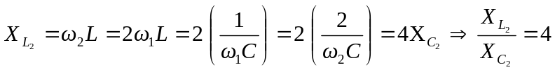, and so the inductor’s reactance is greater than that of the capacitor.
b) 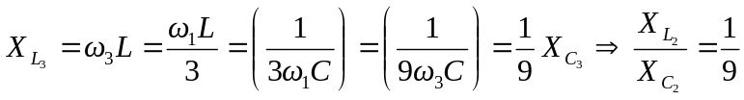, and so the capacitor’s reactance is greater than that of the inductor.
c) Since 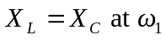, that is the resonance frequency.

